SWT 22022 – Practical for Internet Application Development
Department of Information and Communication Technology
Faculty of Technology
Lab sheet :14
Reg. Number: SEU/IS/20/ICT/084
Academic Year :2020/2021
Date: 2024.07.24
Practical No :15

Title:
- HR Management System - 1

Aims:
- Create Laravel project
- Connect with database
- Implement APIs

Tasks:
- Create new project
- Start Laravel's local development server
- Create a database
- Add database to the project
- Run migrations
- Create a model
- Add variables to the model
- Update migrations
- Create a controller
- Implement CRUD operation
- Implement routes
- Test APIs

Activities :

1. Create new project
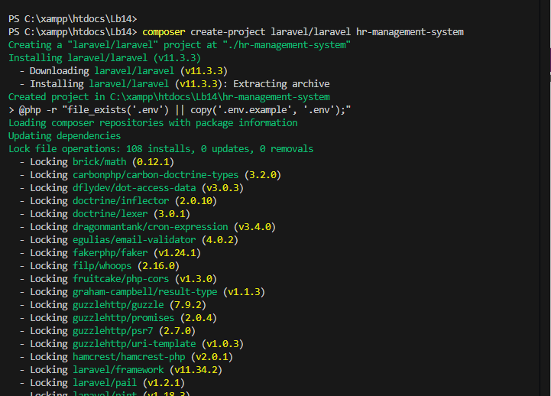
composer create-project laravel/laravel hr-management-system

2. Start Laravel's local development server
cd hr-management-system
php artisan serve
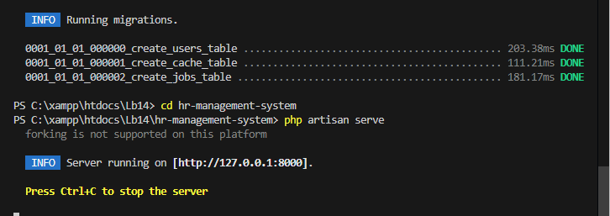

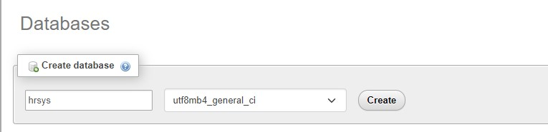
3. Create a database

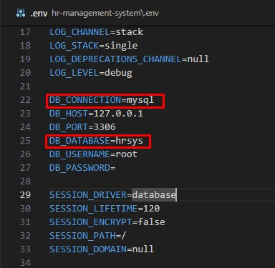
4. Add database to the project

5. Run migrations
php artisan migrate
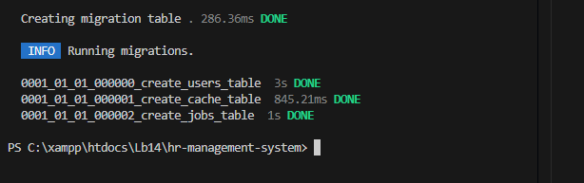

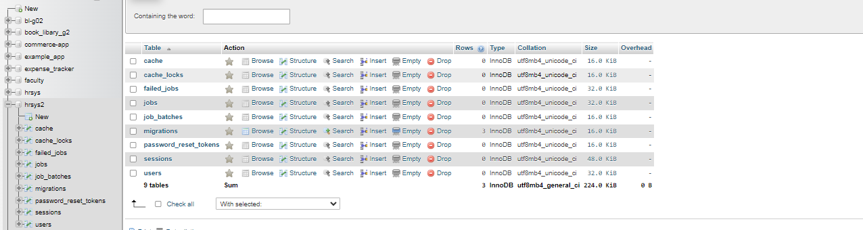

6. Create a model
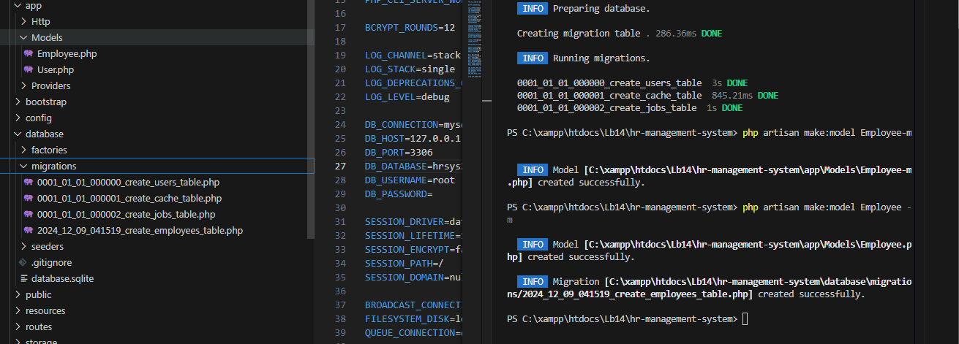
php artisan make:model Employee -m
7. Add variables to the Model
use Illuminate\Database\Eloquent\Model;
class Employee extends Model
{ use HasFactory;
protected $fillable = [
'name',
'role',
'salary',
'age'
];
}

<?php

namespace App\Models;

use Illuminate\Database\Eloquent\Factories\HasFactory;
use Illuminate\Database\Eloquent\Model;

class Employee extends Model
{
use HasFactory;
protected $fillable = [
'name',
'role',
'salary',
'age'
];
}

8. Update migrations
public function up(): void
{
Schema::create('employees', function (Blueprint $table) {
$table->id();
$table->string('name')->nullable();
$table->string('role')->nullable();
$table->decimal('salary',10,2)->nullable();
$table->integer('age')->nullable();
$table->timestamps();
});
}

php artisan migrate

<?php

use Illuminate\Database\Migrations\Migration;
use Illuminate\Database\Schema\Blueprint;
use Illuminate\Support\Facades\Schema;

return new class extends Migration
{
/**
* Run the migrations.
*/
public function up(): void{
Schema::create('employees', function (Blueprint $table) {
$table->id();
$table->string('name')->nullable();
$table->string('role')->nullable();
$table->decimal('salary',10,2)->nullable();
$table->integer('age')->nullable();
$table->timestamps();
});
}

/**
* Reverse the migrations.
*/
public function down(): void
{
Schema::dropIfExists('employees');
}
};

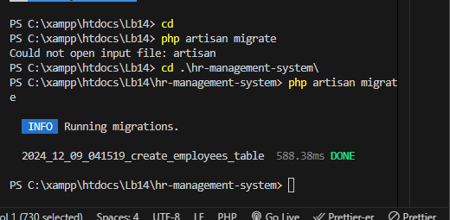

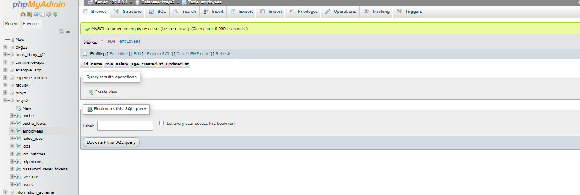
9. Create a controller
php artisan make:controller EmployeeController
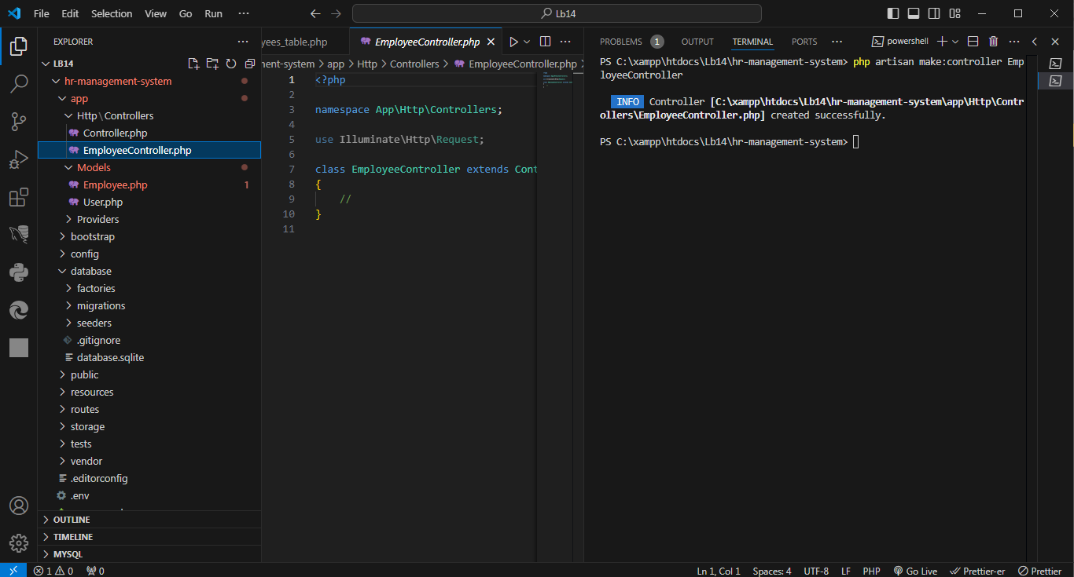

10. Implement CRUD operation

public function store(StoreEmployeeRequest $request)
{
Employee::create($request->validated());
} public function all()
{ return Employee::all();
} public function get($id)
{ return Employee::findOrFail($id);
} public function edit($id)
{
return Employee::findOrFail($id);
} public function update(Request $request, $id)
{
$employee = Employee::findOrFail($id); return $employee->update($request->all());
}
public function delete($id)
{
$employee = Employee::findOrFail($id); return $employee->delete();
}
<?php

namespace App\Http\Controllers;

use App\Http\Requests\StoreEmployeeRequest;
use App\Models\Employee;
use Illuminate\Http\Request;

class EmployeeController extends Controller
{

public function store(StoreEmployeeRequest $request){
Employee::create($request->validated());
}
public function all(){
return Employee::all();
}
public function get($id){
return Employee::findOrFail($id);
}
public function edit($id){
return Employee::findOrFail($id);
}
public function update(Request $request, $id)
{
$employee = Employee::findOrFail($id);
return $employee->update($request->all());
}
public function delete($id){
$employee = Employee::findOrFail($id);
return $employee->delete();
}
}

11. Implement routes
Route::get('/token', function () { return csrf_token(); });
Route::post('employee', [EmployeeController::class, 'store']);
Route::get('employee/all', [EmployeeController::class, 'all']);
Route::get('employee/{id}/edit', [EmployeeController::class, 'edit']);
Route::post('employee/{id}', [EmployeeController::class, 'update']);
Route::delete('employee/{id}', [EmployeeController::class,
'delete']);

<?php

use Illuminate\Support\Facades\Route;

Route::get('/', function () {
return view('welcome');
});

Route::get('/token', function () {
return csrf_token();
});

Route::post('employee', [EmployeeController::class, 'store']);
Route::get('employee/all', [EmployeeController::class, 'all']);
Route::get('employee/{id}/edit', [EmployeeController::class,'edit']);
Route::post('employee/{id}', [EmployeeController::class, 'update']);
Route::delete('employee/{id}', [EmployeeController::class,'delete']);

php artisan make:request StoreEmployeeRequest

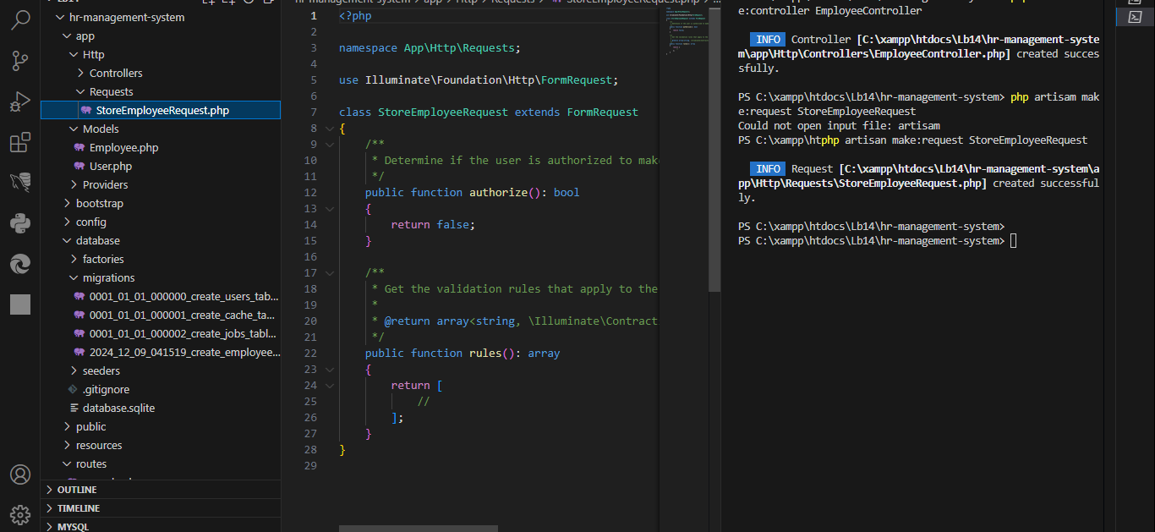
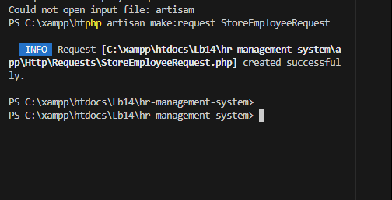

12. Test APIs

Discussion:
- During this lab session, I gained hands-on experience in building a basic HR Management System using Laravel. The process began with creating a new Laravel project and starting the local development server to set up the working environment. I created and configured a database, connecting it to the Laravel project through the .env file, ensuring smooth communication between the application and the database. I then ran migrations to define the initial database schema and created a model to represent the employee data, adding the necessary attributes for the system. This was followed by updating migrations to include specific fields, reflecting real-world HR requirements like name, email, position, and salary. I created a controller to handle the business logic and implemented CRUD operations to manage employees effectively. Routes were defined to link API endpoints with controller actions, facilitating proper interaction between the client and server. Finally, I tested the APIs using tools like Postman, validating the functionality of each operation. This practical session helped me understand the end-to-end process of developing a Laravel-based application, reinforcing key concepts in database management, routing, and API implementation.

